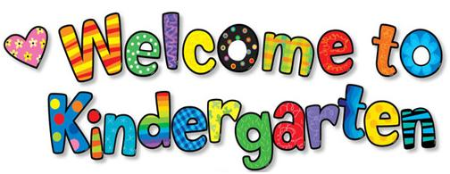

**2024-2025 Student Supply List**

**Kindergarten children will require the following school supplies:**

* 1 large backpack
* 3 large glue sticks
* 1 pair of blunt scissors
* 2 white erasers
* 1 container of playdoh
* 1 pair of indoor Velcro running shoes
* 1 spare set of clothing labelled with child’s name
* 2 box of Kleenex
* 2 large Ziplock plastic bags
* 1 non-breakable water bottle (to be taken home each day for cleaning)

**Please note:**

* Velcro running shoes are recommended for inside wear (unless your son or daughter can tie laces tightly and independently).
* We ask that everything sent to school is labeled with your child’s name (backpack, shoes, coats, scarves, hats, mitts, winter boots).